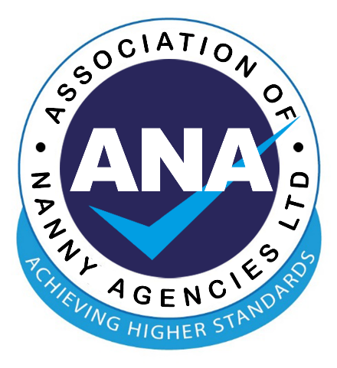

MISSION STATEMENT OF THE ASSOCIATION OF NANNY AGENCIES LIMITED (ANA)
March 2023

ANA’s mission is to promote and raise the standards of professionalism within the nanny industry.

We will do this by upholding the following objectives:

- to promote ANA’s professional standards among all nanny and childcare agencies and those employed or engaged through them.

- to ensure all ANA members perform all reasonable checks regarding the applicant’s identity and overall suitability, including childcare skills and experience, DBS status, professional qualifications and reference checks.

- to raise awareness of ANA and their expected Code of Best Practice.

- to partner with industry specialists to develop standards and good practice guidance within the childcare industry.

- to ensure that all ANA Members carry out their business according to the agreed standards in our Code of Best Practice.

- to provide a network of likeminded agencies to work together collaboratively and support each other.

Updated: March 2023
To be reviewed every 12 months

