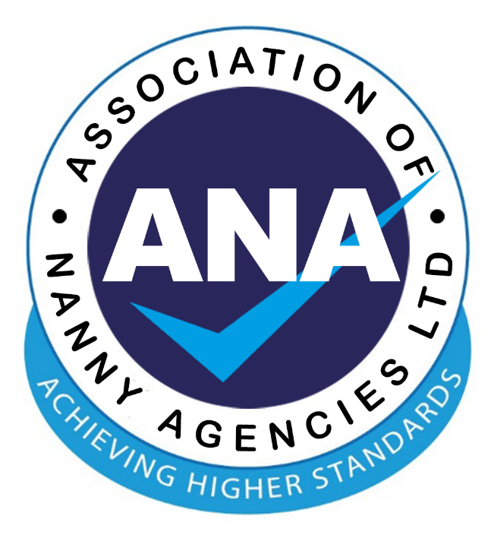

Association of Nanny Agencies Limited
Standards of Best Practice

March 2023

CONTACTS

Chairperson: Samantha Heywood committee@anauk.org
Vice Chair: Abigail Plested committee@anauk.org

Association of Nanny Agencies Limited,
124 City Road,
London EC1V 2NX
Mobile: 07513 702 091
info@anauk.co.uk www.anauk.org

Best Practice Standards

- ANA Members will ensure that all stages of the recruitment process comply with equal opportunities and current legislation.

- ANA Members will aim to develop and maintain a satisfactory knowledge of the childcare and recruitment industry.

- Applicants will be provided with full and relevant information on the family upon an interview being arranged.

- ANA Members will not give misleading information in an attempt to influence a client’s or applicant’s decision.

- ANA recommends all Members ensure their clients and applicants have an understanding of the gross, net and total cost figures as appropriate for their needs.

- Members will only advertise genuine positions, with no misleading information. Positions should state whether they are temporary or permanent and the gross salary offered.

- ANA Members will respect the confidentiality of both the applicant and the client.

- If information comes to light that an applicant on their books is or maybe unsuitable to work with children, members will take appropriate action.

All ANA Members MUST adhere to the above 'Best Practice Guidelines'. Any Member found not doing so will be helped to correct any inadvertent mistakes. However, if the ANA Member repeatedly does not adhere to our Codes and best practice, the membership of that Agency will be withdrawn.

